Public Consultation on TTIP Sustainability Impact Assessment

Annex to EPHA Contribution | June 2016



# Public Consultation on TTIP Sustainability Impact Assessment: Annex to EPHA contribution

## Unhealthy diets are the leading cause of ill-health in the EU

**Societal burden of NCDs in Europe**

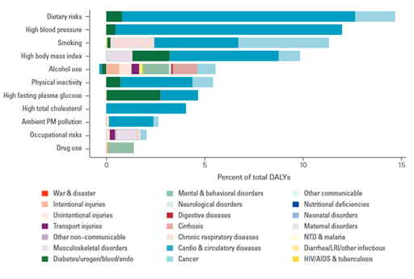Non-Communicable diseases (NCDs) are the root cause of mortality and ill-health in the European region. The four major NCDs, cardiovascular disease (CVD), cancer, respiratory diseases and diabetes, account for almost 86% of premature mortality (death before the age of 70) and 77% of morbidity.[1] Thus putting an increasing burden on economic development, health systems and well-being of large parts of the EU population.

Figure 1: “Disability adjusted life years lost” by risk factors, EU and EFTA, 2010 (The Global Burden of Disease)[2]

NCDs are in large part preventable conditions, leading to premature deaths.[3]

Unhealthy diets, also referred to as dietary risks, are directly linked to the development of NCDs and other chronic conditions such as overweight and obesity. Dietary risks are the single largest risk factor for “disability adjusted life years lost” (DALYs) in the EU.[4] [5] High blood pressure, high body mass index, high blood glucose and high total cholesterol, other primary risk factors, are also closely linked to diets and nutrition.

|  |
| --- |
| **A healthy diet?**  Recommendations for a **healthy diet** includeeating more vegetables, fruit, legumes, nuts and whole grains, while cutting down on salt, sugar and fats.[6]  The bulk of **unhealthy diets** consists of foods high in energy and saturated fats, trans-fats, sugar, salt and refined carbohydrates.[7] |

**The link between NCD risk factors and overweight and obesity**

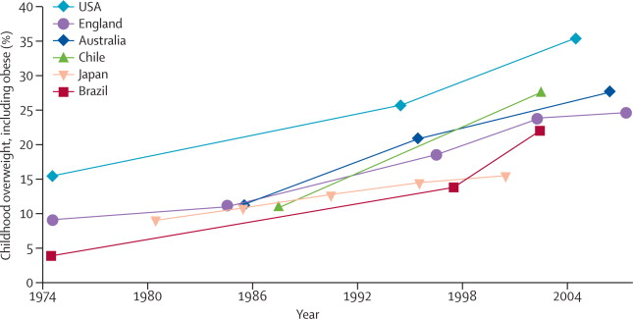The most recent WHO European Health Report 2015 shows progress in tackling mortality from NCDs, but warns of the high prevalence of smoking and alcohol-related harm and the continuing rise in overweight and obesity. The WHO concludes that “obesity is one of the greatest public health challenges of the 21st century.”[8] Overweight and obesity rates have doubled or tripled since the mid-1970s throughout various countries in the world.[9]

Evolution of childhood overweight and obesity in a selection of countries in: Boyd Swinburn et al. (2009) The Lancet

|  |
| --- |
| Obesity is linked to high consumption of processed foods and sugar-sweetened beverages (SSB). [10] Epidemiological studies clearly indicate that “regular consumption of SSBs can lead to weight gain and substantially increase risk of developing NCDs” |

The above mentioned reduced mortality rates reflect on longevity without any indications of life quality[11] and should therefore not be confused with “Healthy Life Years” gained or “Disability-Free Life Expectancy”.

|  |
| --- |
| **“Healthy Life Years” or “Disability-Free Life Expectancy**”[12]  Measures of yearslived in health: Indicating the number of years lived without disability or disease  Used to monitor health as a productive/economic factor introducing the concept of quality of life and employability of older workers |

**Economic impact of NCDs, overweight and obesity**

Looking beyond the health impact, there is also an economic perspective that must be considered. A strong immediate relationship between improved health, in the form of reduced mortality and increased “Healthy Life Years”, and economic gain has been identified.[13]

Evidence indicates that over the course of a lifetime costs for the obese compared to the non-obese population may be higher. This is particularly the case when indirect costs such as lost work productivity, disability and quality of life are factored in alongside with premature mortality and direct medical costs.[14]

|  |
| --- |
| CVD, as the leading cause of death accounting for 40% of all deaths in the EU[15], has estimated costs to the EU economy of €196 billion per year[16].  In 2005, the costs of obesity and overweight to the EU were estimated at €81 billion[17]  In 2010, the annual health care cost burden in the US associated with obesity was estimated to be as high as $209.7 billion[18] |

NCDs and other chronic conditions for example overweight or obesity, have an impact on labour-market performance, consumption patterns and human-capital accumulation. [19]

Health expenditures for an obese person are seen to be 25% higher compared to a normal weight person in any given year. [20]

Obesity is responsible for at least 1-3% of total health expenditures in most OECD countries.[21]

Obese people earn up to 18% less than people with normal weight [22]

**Societal and economic burden of tobacco**

In 2012, 28% of all EU citizens and 29% of people aged 15-24% smoked.

Tobacco use causes 70, 000 deaths per year in the EU,[23] with an additional 13 million people suffering from the main tobacco-related diseases: bronchitis and other lower respiratory infections, chronic obstructive pulmonary diseases (COPD), cardiovascular diseases, asthma, lung cancers and other cancers.[24] Treatment for the six main tobacco-related diseases costs around €25 billion per year, and productivity losses for the EU economy from these diseases amount to €8 billion per year.[25]

Obesity ‘epidemic’ linked to globalisation of supply chains, foreign direct investment & rise of transnational food companies

A correlation between the rise in overweight and obesity and a country’s integration into globalised food supply chains has been observed.[26] [27] Foreign direct investment (FDI) by transnational food companies has been identified as a particularly potent indicator of increased availability and accessibility of highly processed foods high in fat, sugar and salt (HFSS).[28]

|  |
| --- |
| Changes in the food system have in particular:  Increased availability of cheap, highly palatable, energy-dense food;  Enhanced accessibility and convenience of such foods through improved distribution systems and lower relative prices;[29]  Made food marketing more pervasive. |

By altering the local availability, nutritional quality and desirability of foods, these changes affect population diets and raise increasing concerns about the development of obesity and NCDs.[30] [31]

The idea behind trade liberalisation is that enhanced competition will result in lower consumer prices, increasing the ‘consumer surplus’. This vision automatically assumes that increased consumption of goods is beneficial for both consumers and total welfare. In the case of processed foods and tobacco this is not the case. Products high in saturated fat, sugar, salt, highly refined carbohydrates, processed meats and tobacco should be consumed with care!

**Globalised food chains and the global rise in overweight and Obesity; Examples from other regions**

|  |
| --- |
| **Central America**  Between 1985 and 2000 average tariffs declined from 45% to 8%. Between 1990/92-2003/05 total food imports into Central American countries have more than doubled. Analysis suggest that, changes in food availability associated with trade liberalization were likely to have facilitated dietary changes, towards increased consumption of HFSS foods. Changes are further associated with the growing burden of obesity and NCDs in the region. [32] [33]  NAFTA and Mexico’s Obesity Problem: From 1988 to 1999, the period in which NAFTA was negotiated, signed and put into effect,  The average energy from fat in the Mexican diet increased from 23.5% to 30.3%;  Consumption of total carbohydrates declined from 59.7% to 57.5%;  Consumption of refined carbohydrates increased – rising by 6.3%;  Soda consumption increased by 37.2%.  From this data we can observe that NAFTA implementation has coincided with the significant rise in the incidence of overweight and obesity in Mexico. |
| **Pacific Islands**  Increased availability and decreased prices of processed food, attributable to the reduction of tariffs, were associated with the increased consumption of HFSS foods of the people in the Pacific Island countries.[34] Increased consumption of processed foods is in turn linked to the increased incidence in NCDs in the region.[35] |

|  |  |
| --- | --- |
| Looking at the specific example of the Fiji Islands and Samoa which traditionally had high tariffs on processed foods; with trade liberalization these were significantly reduced. Resulting in a dramatic increase in imports of processed, pre-packed foods into both countries.[36] |  |

Although the examples from Central America and the Pacific Islands cannot fully be translated into the EU-US context as the EU and US are two high-income countries and the changes in the food environment are likely to be not as extreme as observed in other parts of the world; the examples demonstrate how the reduction of tariffs resulted in unhealthy foods becoming available to consumers at lower prices and how this facilitated the rise in overweight and obesity in both regions.

The European Union should learn from other countries’ experience and prevent that further liberalization in trade of unhealthy products will lead to a further increase of overweight and obesity in the Union.

Pricing policy of unhealthy products

**Price as a major determinant of consumption**

The price of a product is the primary determinant of consumer choices. [37] The sensitive response to price changes can particularly be seen in low socioeconomic groups and among young people. [38]

Several studies found that food products for which consumers are especially responsive to price changes are: SSBs, foods eaten away from home, meats and processed foods. For these food groups higher prices were associated with significantly lower consumption. [39] [40] [41]

Figure 2 presents the relationship of increased obesity rates in children and adults and selected food and beverage prices. As prices of fruits and vegetables increased, prices for carbonated drinks (a type of SSB) decreased and obesity rates simultaneously increased. [42]

Figure 2: Trends in selected food and beverages prices and obesity rates among children and adults in the U.S. 1980-2011

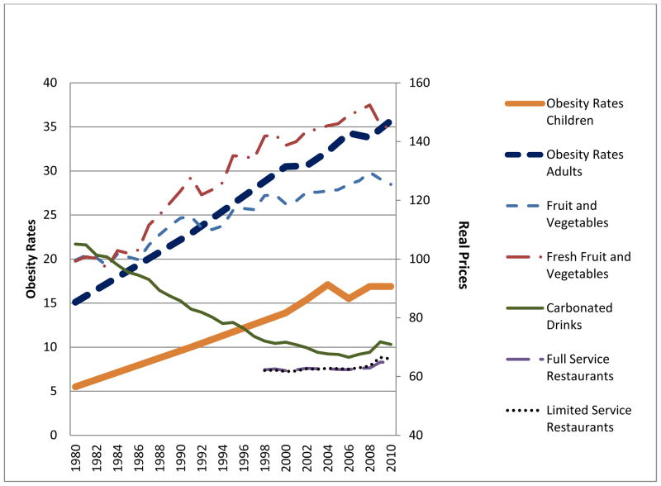

|  |
| --- |
| **The Case of Tobacco**  Research suggests that liberalisation of trade in tobacco has opened countries to competition from lower priced foreign tobacco products, resulting in lower prices and higher consumption in the importing country.[43] [44] Evidence suggests that young people and people with low incomes are likely to be more responsive to tax and price increases, for several reasons:   1. The proportion of disposable income spent on cigarettes is likely to be greater among young smokers. 2. Young people have a greater propensity to discount the future costs of smoking in terms of the associated health consequences and place greater emphasis on the short-term costs, such as the price of tobacco.[45] 3. young people are more likely to have a shorter smoking history than adults and therefore be more responsive to a change in price than those who are more addicted.[46]   Current evidence shows that price increases in tobacco have considerably contributed to reductions in tobacco use among youth and adults.[47] |

Given that consumers react to price incentives when making food and tobacco choices,[48] any development that could encourage the lowering of prices in unhealthy foods and tobacco would probably result in a further deterioration of dietary patterns and overall health.

**Key pricing determinants of consumer prices: taxes, excise duties, tariffs/third country duties**

The price of a product is determined by many factors. The key pricing determinants are taxes, excise duties and tariffs/third country duties.

* Taxation
* Taxes are not covered by trade and investment agreements.
* Excise duties

Excise duties are indirect taxes on the sale or use of specific products. They are usually applied as an amount per quantity of the product e.g. per kg / per hl /per degree alcohol / per 1000 pieces etc. All revenue from excise duties goes entirely to the Member States. In the EU, Member States must apply excise duties to unhealthy products such as alcohol and tobacco.[49] Excise duties are not covered by trade and investment agreements.

**Tariffs/third country duties**

Tariffs/third country duties are both forms of taxes imposed by the government on goods which are imported from some other country. While the primary aim of a tariff helps protect the domestic industries in the market of a country by restricting the amount of goods traded and generates revenue for the government, it is a key determinant of product price. That means that in the case of unhealthy products such as unhealthy food or tobacco, tariffs/third country duties are serving public health purposes too by keeping the product price higher. Removing tariffs/third country duties would have direct and indirect impact on public health. The direct impact would be to make third country products cheaper which would increase the competition on the internal market. The indirect impact would be increased competition leading to higher availability of those products and resulting in a general pressure on lowering the prices of all products within the EU.

Pursuant to TFEU article 168, the EU has to take into account public health aspects during tariffs/third country duties negotiations and could exclude them from free trade and investment agreements. Reducing tariffs/third country duties and relying only on taxation and excise duty policies concerning the price of unhealthy food and tobacco would – de facto – mean reducing their prices and increasing their availability which is in light of the presented evidence, is contrary to the EU’s obligation to improve population health.

**Tariff/ third country duty reduction could result in processed foods high in saturated fat, sugar and salt (HFSS) and tobacco products becoming available to consumers at lower prices.**

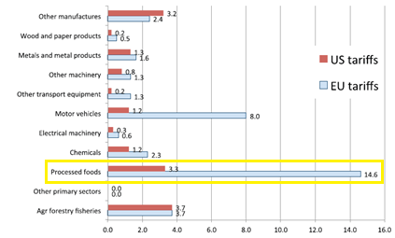The 2013 Centre for Economic Policy Research (CEPR) study on TTIP conducted for DG Trade found that, compared to any other EU sector, processed foods are covered by the highest average tariffs (14.6%).

Figure 3: Average tariff rates applicable to different sectors (CEPR)

**Current tariff rates/third country duties in the EU/US context**

The following graphs present the current EU tariff rates on different processed food products and tobacco: [50]

* **Sausages and similar products**

Sausages and similar products of meat and food preparations based on these products are currently covered by a tariff rate of 15.40%.

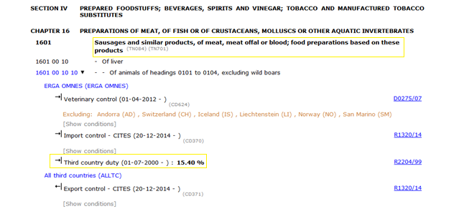

* **Sugar confectionery**

Sugar confectionery is currently covered by tariff rates ranging from 8.30% to 43%.

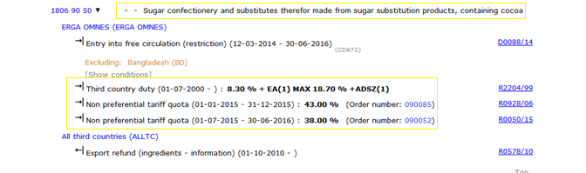

* **Sweet biscuits**

Tariff rates on sweet biscuits range from 9.00% to 24.20%

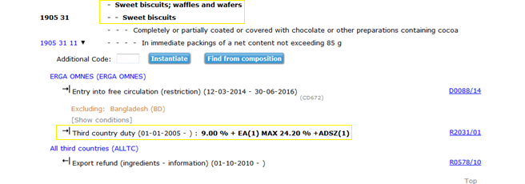

* **Savoury snacks**

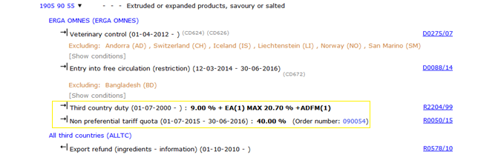

* **Tobacco Products**

Tariff rates on tobacco products range from 10.0% to 57.60%

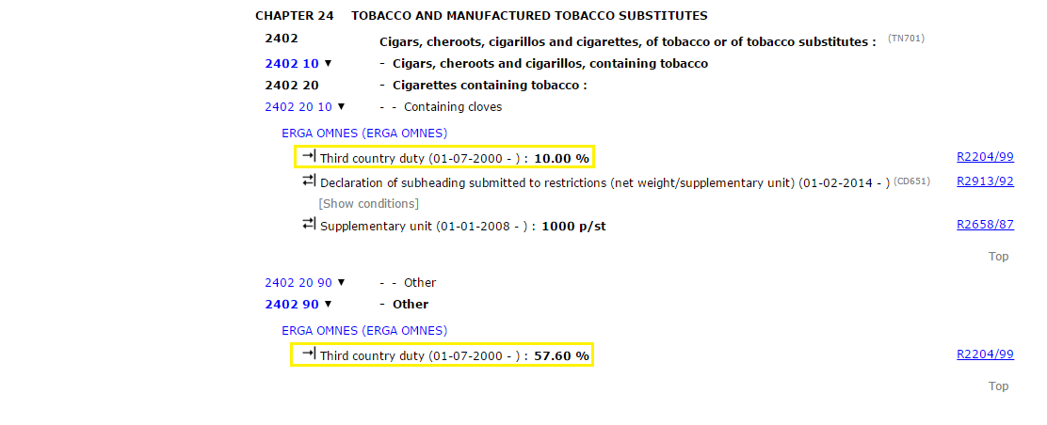



According to an information brochure by the Atlantic Council, Bertelsmann Foundation and British Embassy in Washington, US processed food exports, in particular involving "*meat, dairy, and seafood products, milled grains, confections, preserves and specialty foods, baked goods, as well as beverages*", are expected to increase by 102% by 2027.[51] A study conducted for the European Commission predicts a large increase in the trade of processed foods, assuming tariffs will be significantly reduced or abolished under TTIP.[52]

Reductions in tariffs/third country duties will result in greater amounts traded, increased competition and a downward pressure on prices for processed foods, affecting diet-related health.[53] In the case of processed HFSS food careful attention is needed, as small increases in consumption of products high in saturated fat, sugar, salt, highly refined carbohydrates, processed meats, could lead to weight gain and/or cause other health implications.[54]

## About EPHA

EPHA is a change agent – Europe’s leading NGO advocating for better health. We are a dynamic member-led organisation, made up of public health NGOs, patient groups, health professionals, and disease groups working together to improve health and strengthen the voice of public health in Europe. EPHA is a member of, among others, the Social Platform, the Health and Environment Alliance (HEAL), the EU Civil Society Contact Group and the Better Regulation Watchdog.

EPHA's Transparency register number is 18941013532-08.

1. WHO Europe (2014). Prevention and Control of Non-Communicable Diseases in the European Region: a progress report
2. The graph is an outcome of the “Global Burden of Disease” study (2013), a collaboration between seven leading international scientific institutes to systematically quantify the main causes of health loss.
3. WHO Europe (2014). Prevention and Control of Non-Communicable Diseases in the European Region: a progress report
4. Institute for Health Metrics and Evaluation. University of Washington (2013) The global burden of disease. Generating evidence, guiding policy. European Union and European Free Trade Association Regional Edition. [[online](http://www.healthdata.org/sites/default/files/files/policy_report/2013/The%20Global%20Burden%20of%20Disease_Generating%20Evidence%2C%20Guiding%20Poliy%20-%20European%20Union%20and%20Free%20Trade%20Association.pdf)]
5. The Disability Adjusted Life Year (DALY) is a measure of overall disease burden expressed as the number of years lost due to ill-health, disability or early death. The measure combines mortality and disease into one indicator.
6. WHO (2015) Healthy Diet. Fact sheet No 394. [[online](http://www.who.int/mediacentre/factsheets/fs394/en/)]
7. WHO (2015) Healthy Diet. Fact sheet No 394. [[online](http://www.who.int/mediacentre/factsheets/fs394/en/)]
8. WHO Europe (2015) European Health Report 2015. [[online](http://www.euro.who.int/__data/assets/pdf_file/0006/288645/European-health-report-2015-Targets-beyondreaching-new-frontiers-evidence-full-book-en.pdf?ua=1)]
9. Franco Sassi (2010) Obesity and the Economics of Prevention – Fit not fat. OECD. [[online]](http://www.oecd.org/els/health-systems/obesity-and-the-economics-of-prevention-9789264084865-en.htm)
10. Frank B. Hu, & Vasanati S. Malik. (2010). Sugar-sweetened beverages and risks of obesity and type 2 diabetes: Epidemiological evidence. Physiology & Behaviour
11. European Commission. DG Health website. Healthy Life Years. [[online](http://ec.europa.eu/health/indicators/healthy_life_years/index_en.htm)]
12. European Commission. DG Health website. Healthy Life Years. [[online](http://ec.europa.eu/health/indicators/healthy_life_years/index_en.htm)]
13. Oxford Health Alliance (2006). Chronic disease: an economic perspective [[online](http://ajcn.nutrition.org/content/early/2009/10/14/ajcn.2009.28595.short)]
14. OECD. (2010) Obesity and the Economics of prevention: fit not fat [[online](http://ajcn.nutrition.org/content/early/2009/10/14/ajcn.2009.28595.short)]
15. WHO Europe (2016) Health topics. Non-Communicable Diseases. Cardiovascular diseases. [[online](http://ajcn.nutrition.org/content/early/2009/10/14/ajcn.2009.28595.short)]
16. Nichols M, Townsend, N, Scarborough P, Luengo-Fernandez R, Real J, Gray A, Rayner M (2012); European Cardiovascular Disease Statistics 2012. European Heart Network, Brussels, European Society of Cardiology, Sophia Antipolis [[online](http://ajcn.nutrition.org/content/early/2009/10/14/ajcn.2009.28595.short)]p
17. European Commission (2007). Impact Assessment Repot – A Strategy for Europe on Nutrition, Overweight and Obesity related health issues.
18. Lisa Powell et. Al. (2013). Assessing the Potential Effectiveness of Food and Beverage Taxes and Subsidies for Improving Public Health: A systematic Review of Prices, Demand and Body Weight Outcomes
19. Oxford Health Alliance (2006). Chronic disease: an economic perspective [[online](http://ajcn.nutrition.org/content/early/2009/10/14/ajcn.2009.28595.short)]
20. OECD. (2010) Obesity and the Economics of Prevention: fit not fat [[online](http://ajcn.nutrition.org/content/early/2009/10/14/ajcn.2009.28595.short)]
21. OECD. (2010) Obesity and the of Economics of Prevention: fit not fat [[online](http://ajcn.nutrition.org/content/early/2009/10/14/ajcn.2009.28595.short)]
22. OECD. (2010) Obesity and the Economics of Prevention: fit not fat [[online](http://ajcn.nutrition.org/content/early/2009/10/14/ajcn.2009.28595.short)]
23. Impact Assessment accompanying the Proposal for a Directive of the European Parliament and of the Council on the approximation of the laws, regulations and administrative provisions of the Member States concerning the manufacture, presentation and sale of tobacco and related products. European Commission December 2012. http://ec.europa.eu/health/tobacco/docs/com_2012_788_ia_en.pdf
24. European Commission. (2011) Press Release Database. Q&A: The Fight Against Tobacco in the EU
25. James Reilly, Minister of Health intervention, ENVI public hearing on the Tobacco Products Directive, 25 February 2013
26. Boyd Swinburn et al. (2009) Increased food energy supply is more than sufficient to explain the US epidemic of obesity. Am J Clin Nutr. [[online](http://ajcn.nutrition.org/content/early/2009/10/14/ajcn.2009.28595.short)]
27. Yevgeniy Goryakin et al. (2015) The impact of economic, political and social globalization on overweight and obesity in the 56 low and middle income countries. The Lancet. [[online](http://www.sciencedirect.com/science/article/pii/S0277953615001744)]
28. Corinna Hawkes (2005) The role of foreign direct investment in the nutrition transition. Public Health Nutr. [[online](http://www.ncbi.nlm.nih.gov/pubmed/15975180)]
29. Steve Wiggins et al. (2015) The rising cost of a healthy diet – changing relative prices of food in high income and emerging economies. Overseas Development Institute, UK. [[online]](http://www.odi.org/sites/odi.org.uk/files/odi-assets/publications-opinion-files/9580.pdf)
30. Corinna Hawkes (2006) Uneven dietary development: linking the policies and processes of globalization with the nutrition transition, obesity and diet-related chronic diseases. BioMed Central. [[online]](http://www.odi.org/sites/odi.org.uk/files/odi-assets/publications-opinion-files/9580.pdf)
31. Sharon Friel et. Al. (2013). A new generation of trade policy: potential risks to diet-related health from the trans-pacific partnership agreement
32. Anne Marie Thow & Corinna Hawkes (2009). The implications of trade liberalization for diet and health: a case study from Central America. In Globalization and Health
33. Corinna Hawkes, Sophia Murphy & David Wallinga (2011). Exporting Obesity: How U.S. Farm and Trade Policy is Transforming the Mexican Consumer Food Environment
34. World Health Organization (2002). Globalization, Diet and Non-Communicable Diseases
35. Wendy Snowdon et. Al (2013). Processed foods available in the Pacific Islands
36. Anne Marie Thow et. Al. (2011). Trade and the Nutrition Transition: Strengthening Policy for Health in the Pacific
37. Andreyeva, Tatiana (2010). The Impact of Food Prices on Consumption: A systematic Review of Research on the Price Elasticity of Demand for Food
38. http://www.ncbi.nlm.nih.gov/pubmed/12946461
39. Andreyeva, Tatiana (2010). The Impact of Food Prices on Consumption: A systematic Review of Research on the Price Elasticity of Demand for Food
40. Lisa M. Powell et Al. (2013). Assessing the Potential Effectiveness of Food and Beverage Taxes and Subsidies for IMproving Public Health: A Systematic Review of Prices, Demand and Body Weight Outcomes
41. Andreyeva, Tatiana (2010). The Impact of Food Prices on Consumption: A systematic Review of Research on the Price Elasticity of Demand for Food
42. Lisa M. Powell et. Al. Assessing the Potential Effectiveness of Food and Beverage Taxes and Subsidies for Improving Public Health: A Systematic Review of Prices, Demand and Body Weight Outcomes
43. E R Shaffer, J E Brenner, T P Houston, International trade agreements: a threat to tobacco control policy. *Tobacco Control*
44. WHO (2014) Raising tax on tobacco what you need to know
45. Chaloupka FJ, Grossman M. Price, tobacco control policies and youth smoking. Cambridge, Massachusetts, National Bureau of Economic Research, 1996. – referred in PPACTE project February 2009 – March 2012. P.27
46. Lewit EM, Coate D, Grossman M. The effects of government regulation on teenage smoking. Journal of Law and Economics, 1981, 24:24. – referred in PPACTE project February 2009 – March 2012. P.28
47. Powell et. A. (2013). Assessing the Potential Effectiveness of Food and Beverage Taxes and Subsidies for Improving Public Health: A systematic Review of Prices, Demand and Body Weight Outcomes
48. WHO Europe (2015) Using price policies to promote healthier diets. [[online](http://www.euro.who.int/__data/assets/pdf_file/0008/273662/Using-price-policies-to-promote-healthier-diets.pdf)]
49. <http://ec.europa.eu/taxation_customs/taxation/excise_duties/gen_overview/index_en.htm>
50. European Commission TARIC database. [[online](http://ec.europa.eu/taxation_customs/dds2/taric/taric_consultation.jsp)]
51. Atlantic Council, Bertelsmann Foundation, British Embassy in Washington. Processed food and TTIP. [[online](https://www.gov.uk/government/uploads/system/uploads/attachment_data/file/288162/TTIP_and_the_US_Processed_Foods_Sector.pdf)]
52. CEPR (2013) Reducing Transatlantic Barriers to Trade and Investment. An economic assessment. [[online](http://trade.ec.europa.eu/doclib/docs/2013/march/tradoc_150737.pdf)]
53. Friel et. Al. (2013). A new generation of trade policy: potential risks to diet-related health from the trans pacific partnership agreement
54. Commission of the European Communities. (2007). A Strategy for Europe on Nutrition, Overweight and Obesity related health issues. p.18